Vaccine Community Engagement Programme

A joint vaccine community engagement project, supported by London Borough of Newham.

A CALL TO ACTION

Vaccine Confidence Project to engage, communicate and build a vaccine literacy among venerable ethnic minority communities.

 Joined**Partnership**

ADD ALL THE ORGANISATIONS LOGO HERE. <http://newhamsa.org.uk/> <https://www.healtogether.org.uk/>

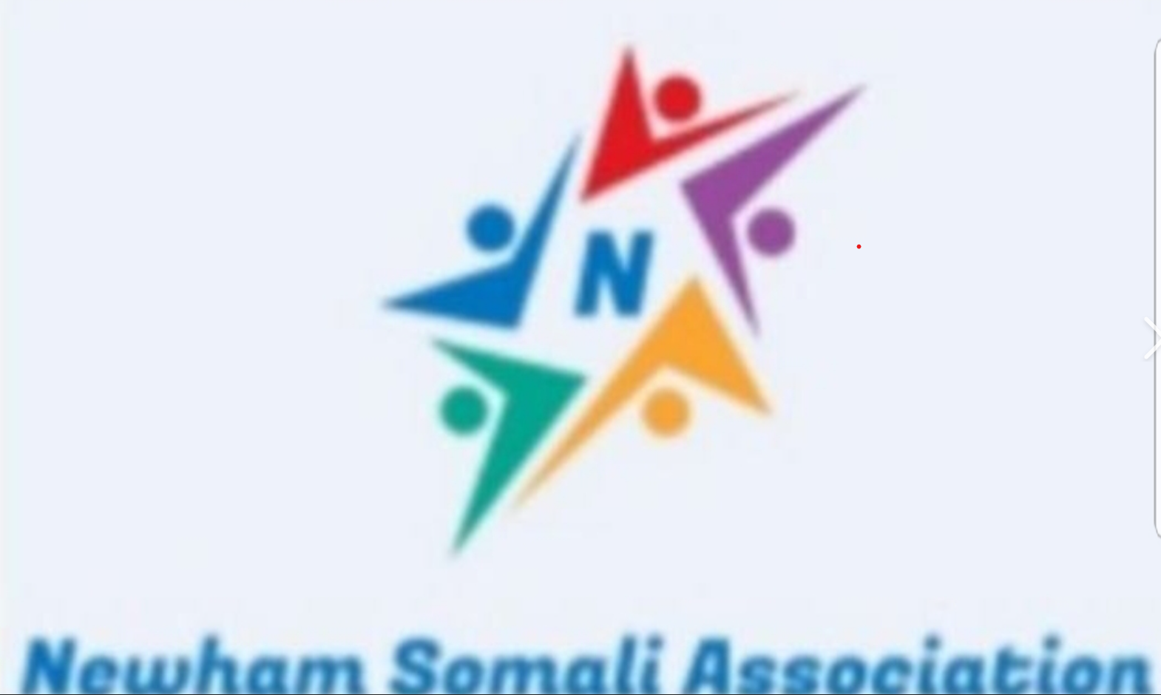

& HEALTOGETHER LOGO HE

RE.

